|  |  |  |
| --- | --- | --- |
| Activity 1  View the video “Cal’s Story”.  Teacher guides students through the worksheet 1 activity. | Subject focus  Identify positive online behaviour and act against cyberbullying behaviour | Resources required  Worksheet 1  “Cal’s Story” accessed via Video resource:   * <http://readnlearnpathfinders.weebly.com/digital-citizenship.html> |
| Activity 2  View the video “Connor’s Story”.  Teacher highlights the positive bystander tips  Students complete Worksheet 2 | Subject focus  Identify negative online behaviour and decide on acceptable responses. | Resources required  Worksheet 2  Positive Bystander Tips  “Connor’s Story” accessed via Video resource:   * <http://readnlearnpathfinders.weebly.com/digital-citizenship.html> |

Terminology referred to:

Cyberbullying, bullying behaviour, bystander, target, online, post, text, email, message, social networking, block, report, trusted adult, harm.

***Background***

Cyberbullying is the use of online technology, such as computers and mobile phones, to bully a person or group. Bullying is repeated behaviour by an individual or group with the intent to harm another person or group.

Young people can cyberbully each other in many ways. Sending hurtful texts or abusive emails, excluding individuals from online conversations, imitating someone online, posting inappropriate images and trolling are some of the ways people can cyberbully each other.

Cyberbullying can happen to anyone and typically involves a person who perpetrates the bullying behaviour against a target – the person being bullied. In some instances there may also be bystanders involved – people who witness someone being cyberbullied. A positive bystander is someone who offers support to the target and does not ignore or participate in the bullying behaviour, such as forwarding on humiliating images.

Cyberbullying is serious because it can be relentless and occur 24 hours a day, extending well beyond school grounds and into ‘safe’ spaces, such as in homes. Its effects can be damaging, making a person feel isolated, friendless, miserable and insecure.

**The Bystander**

**‘All that is necessary for the triumph of evil is that good men do nothing.’**

This has often been quoted by people when commenting on conflicts and human rights abuses around the world, as well as during periods of social change and upheaval such as during historic campaigns for equal rights for women or for indigenous Australians.

The nature of what is meant by ‘evil’ is hard to define, but for our purposes, let’s say it refers to negative, self-serving intentions and actions that may harm others. When a person or a group of people act this way, history shows they will usually continue until stopped.

**Discussion starters:**

**So, what are the reasons ‘good people’ sometimes do nothing?**

**What does it take for a ‘good person’ to finally act?**

Another useful way of looking at the role of the bystander and at power in relationships is to consider the ancient proverb:

**‘There is no Queen without her subjects.’**

A Queen, or any person with power and influence, is a single person. They only have their powerful position due to the complicity of their ‘subjects’ – the great many individual people willing to support and empower that single person.

At a classroom and friendship group level, this same theory can be applied to the most powerful and influential person in a group.

This person may enjoy group support because they are funny, likable and caring. But sometimes it is because they engender a fear of rejection. They bully people and make others too frightened of the negative social consequences of disagreeing with them.

Worksheet 1—CAL’S STORY

# Instructions

In this task you will need to watch Cal’s Story and reflect on Cal’s behaviour.

Bystanders have an important role to play in cyberbullying situations and their actions can help stop the bullying behaviour.

It is not unusual for a bystander to feel uncomfortable confronting a cyberbully on their own, as they may not feel confident or safe enough to do so.

Cal is caught up in the cyberbullying between Jac and Nicola, is not sure what to do and is understandably upset. How could you help Cal rewrite her story?

Use the ideas in the I Can Help and 10 Good responses If Your friend Is Being Cyberbullied to help write at least 10 sentences to rewrite the way Cal responded as a bystander.

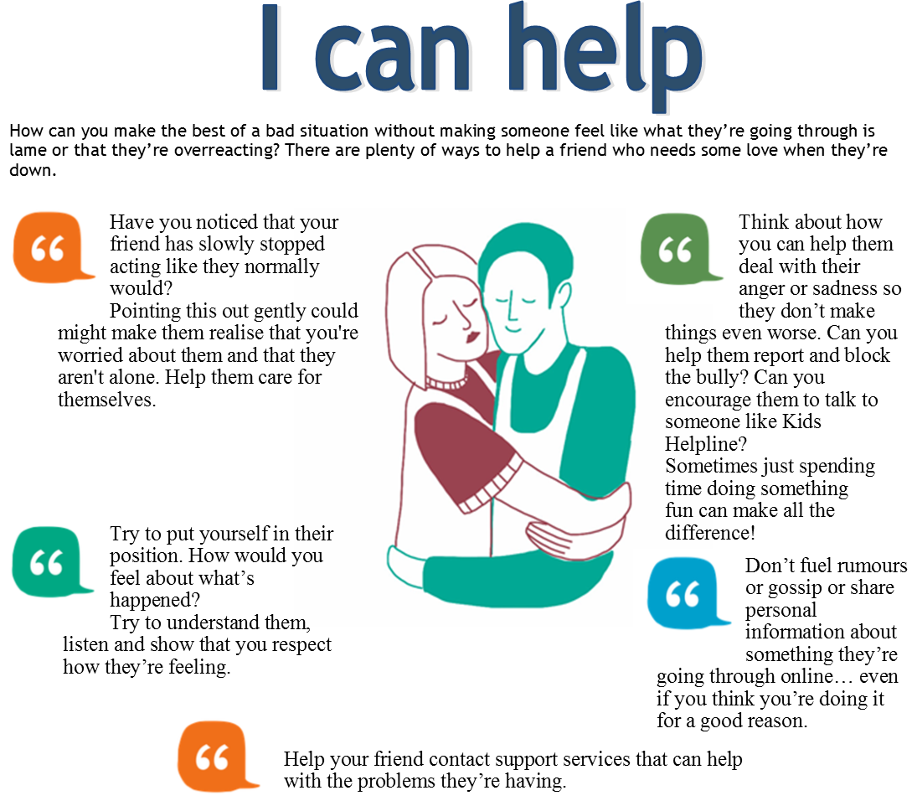

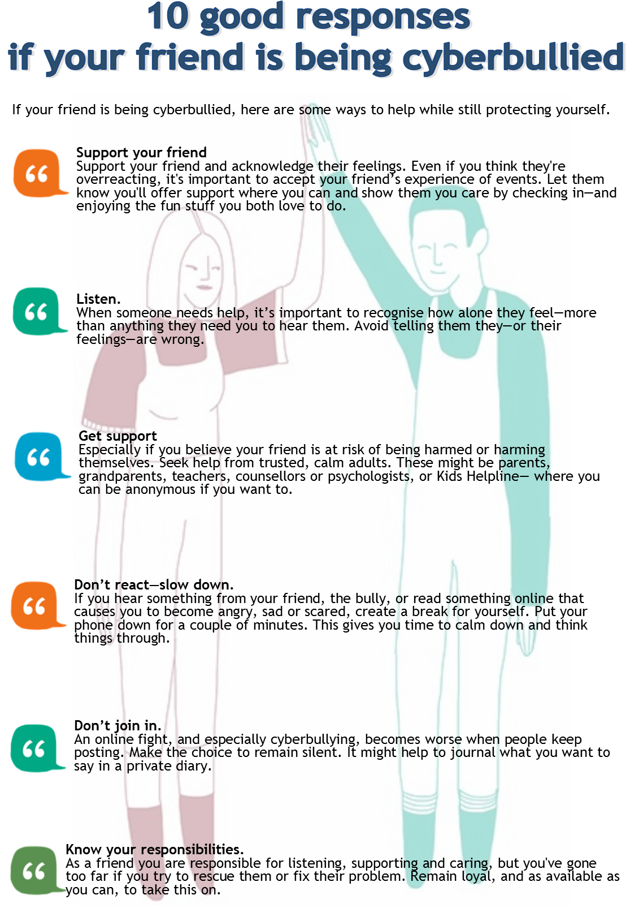

Worksheet 2—CONNOR’S sTORY

Connor already knows what it's like to be made fun of online, but it's all just a joke…right?

Bystanders have an important role to play in cyberbullying situations and their actions can help stop the bullying behaviour.

It is not unusual for a bystander to feel uncomfortable confronting a cyberbully on their own, as they may not feel confident or safe enough to do so.

There are options available if you wish to help someone who is being targeted online.

In this task you will need to watch Connor’s Story and reflect on Connor’s behaviour.

# Questions

Answer the three questions below.

Question 1

|  |  |
| --- | --- |
| 21 seconds | At 50 second mark, Connor comments on Kyle being dropped off at school by his Mum.  Describe how Connor’s behaviour was not helpful to Kyle. What did Connor’s opinion that Kyle “asking for it” tell us about Connor? |

**Question 2**

|  |  |
| --- | --- |
| ***35 seconds*** | Connor explains that he only really only sent one photo to a couple of mates.  Was Connor’s behaviour helpful or not? Why?  Was Connor acting as a bystander? What type of bystander? |

**Question 3**

|  |  |
| --- | --- |
| ***47 seconds*** | Now look at the scene in the Principal’s Office. Connor explains that it was all just a joke.  How did Connor come to change his opinion of the joke? |

# Instructions

1. Think about a time when you may have seen instances of cyberbullying online.
2. Using the **Positive Bystander Tips** and **10 Good Responses If Your Friend Is Being Cyberbullied**, select something positive you could do, or the option that you would feel safest in doing, if you witness someone:

a) repeatedly sending abusive text messages to or about another person ;

b) posting an inappropriately tagged photo of someone in your year group—the photo is humiliating and has attracted many hurtful comments;

c) who is a friend excluding a member of your friendship group from a party posted online.

1. List any of the tips you have used yourself in a cyberbullying situation where someone is a target.

|  |  |
| --- | --- |
| Positive Bystander Tips | |
| Step in  figure_jump_custom_text_13901.png | Do something positive to help the target.  Speak out against the cyberbullying behaviour—if you feel safe doing so. Make it clear you find the behaviour unacceptable and ask for any hurtful texts/posts/images to be deleted.  Encourage the target to get help from a trusted adult. Offer to go with them to make the report and give them information on where to get help. |
| help  grab_my_hand_800_clr_14051.png | * Help in a way you feel comfortable. If you don’t feel comfortable telling the bully to stop, think about ways you can help behind the scenes, such as saving the evidence of the cyberbullying (like screenshots or photos) or helping them check their privacy settings.   Make contact with the target (online or offline). Email/message the target to let them know you feel for them and you don’t agree with the cyberbully’s behaviour.  If you are not sure how to handle the situation, there are professionals and useful websites that can help. Check out the Cybersmart website at [www.cybersmart.gov.au](http://www.cybersmart.gov.au) for useful tips on dealing with cyberbullying. The Kids Helpline also offers free and confidential counselling services on cybersafety issues, including cyberbullying. Visit [www.kidshelp.com.au](http://www.kidshelp.com.au) or call 1800 55 1800. |
| act  arrow_figure_jump_800_clr_13375.png | * Don’t encourage the cyberbully. Choose not to comment on, resend or respond to posts that may offend or upset someone else.   Group action—check with friends if they feel the same about the situation. Discuss what you can do together as a group to help resolve it. This might include sending a group message to those involved in the cyberbullying to stop their behaviour, blocking the main people involved or approaching a trusted adult as a group.  Make it clear to your friends that you will not join in any cyberbullying behaviour. |
| report  stick_figure_pushing_button_800_clr_7475.png | Tell an adult you can trust and has the authority to help. This may be a parent, teacher, school principal, school counsellor, a coach or family member.   * Report cyberbullying to the police if you feel someone’s personal safety has been threatened.   Report anonymously. If you want to protect your identity, think about reporting the situation anonymously. For example, type up a note about what is happening and leave it in the letter box or under the door of an adult who can help.   * Report to an administrator. If you see cyberbullying online, report it to the administrator of the social media website to ask for content to be removed. Contact the relevant mobile phone company in the case of bullying text messages or calls. |
| empathy  introductions_400_clr_10909.png | Show your concern and support. Put yourself in the target’s position—you would want somebody to support you if you were being cyberbullied.  Chat with the target directly and away from an audience. You don’t have to mention the cyberbullying behaviour. Check in with the target and comfort them—this could be done in person or via a text or private message. Your support might reduce any feelings of isolation a target may have. |

**Definitions**

**Sexting**

Sexting refers to the sending of provocative or sexual photos, messages, or videos, generally using a mobile phone. It can also include posting this type of material online.

While sharing sexually suggestive images or text messages may be seen as innocent flirting or amusement for young people, sexting can have serious personal, social and legal consequences.

Under current Australian law, young people may be committing a crime when taking, receiving or forwarding sexual images of themselves or friends who are minors. This applies even if all participants are willing. These acts can represent the production or distribution of child pornography.

**Digital reputation**

Digital reputation, like any other form of reputation, refers to the generalised view others take of a person’s identity. The digital component refers to the evidence of a person’s interactions, comments and behaviours online and how this combines to form a whole impression of an individual.

A digital reputation is as real, lasting and important as an individual’s general reputation. It affects a person’s image and how their identity and beliefs are understood.

**Cyberbullying**

Cyberbullying occurs when the internet, email or mobile phones are used to deliberately and repeatedly engage in hostile behaviour to harm or upset someone. Cyberbullying can result in those involved experiencing social, psychological and academic difficulties.

**Cyberbullying behaviours include:**

• sending abusive texts or emails

• posting unkind messages or inappropriate images on social networking sites

• tagging unflattering, private or offensive images with a person’s name to discredit or hurt them

• impersonating others online

• excluding others online.

This work is based on materials that constitute copyright of the Commonwealth of Australia and is licensed under a Creative Commons Attribution Non-Commercial Share Alike 3.0 Australia Licence. See [http://cybersmart.acma.gov.au/About Cybersmart/Legal.aspx](http://www.cybersmart.gov.au/About%20Cybersmart/Legal.aspx) for more information.

