Referencing 5 Badge

Badge | Description
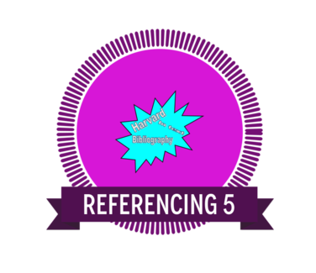 | Being able to apply criteria to verify the integrity and value of the digital data, information and sources using ICT is an essential skill for learning and in the workplace.
Links to the Australian Curriculum  Being able to apply criteria to verify the integrity and value of the digital data, information and sources using ICT is an essential skill for learning and in the workplace.  Select and evaluate data and information  Use criteria systematically to evaluate the quality, suitability and credibility of located data or information and sources. (Investigating with ICT) | Criteria to earn badge  To earn this badge you will:  • Use the SLASA Online Referencing tool.  • Create an annotated reference list.  • Provide an example of in text referencing supported by the reference list.  • This evidence can then be uploaded when the badge is claimed.
Reference list
Subject:
Teacher:
Annotated Referencing list:

In text referencing
Subject:
Teacher:

