Referencing Badge

Badge | Description
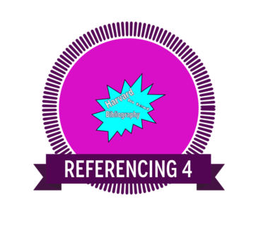 | Recognising intellectual property and consciously applying practices that protect intellectual property is an essential skill for learning and in the workplace.
Links to the Australian Curriculum  Recognising intellectual property and consciously applying practices that protect intellectual property is an essential skill for learning and in the workplace.  The recipient is able to assess the suitability of data or information using a range of appropriate given criteria (Investigating with ICT). | Criteria to earn badge  To earn this badge you will:  - Explore the SLASA Online Reference Generator.  - Create a reference list using the SLASA Online Reference Generator.  - Provide an example of in text referencing supported by the reference list.  - This evidence can then be uploaded when the badge is claimed.
Reference list
Subject:
Teacher:
Referencing list:

In text referencing
Subject:
Teacher:

