Hour of Code Badge

Badge | Description
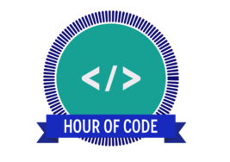 | The Hour of Code is a one-hour introduction to computer science, designed to demystify code and show that anybody can learn the basics. It is important for students to be able to generate solutions to challenges and learning area tasks
Links to the Australian Curriculum  generate solutions to challenges and learning area tasks (Australian Curriculum - Creating with ICT) through being able to design, modify and manage complex digital solutions for a range of audiences and purposes. | Criteria to earn badge  To earn this badge you will:  - Successfully complete a minimum of one activity from the Hour of Code website (verified by their teacher).  - Complete a minimum of three sentences reflecting on what you have learned.  - This evidence can then be uploaded when the badge is claimed.
Hour of Code:
Completed activity/activities:

Reflection on my learning:

Teacher verification:

