Growth Mindset Badge 1

Badge | Description
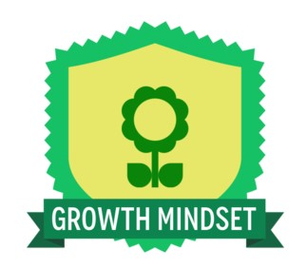 | A growth mindset means the earner believes that fundamental abilities can be improved through commitment and hard work. They believe brains and talent are just the starting point. They embrace challenges and failures as opportunities to grow and improve.
Links to the Australian Curriculum  Reflect on assumptions made, consider reasonable criticism and adjust their thinking if necessary (Think about thinking (metacognition) when reflecting on thinking and processes (Critical and Creative Thinking). | Criteria to earn badge  To earn this badge you will:  - View the video.  - Complete a minimum of 100 words describing how you have demonstrated your growth mindset.  - This evidence can then be uploaded when the badge is claimed.
Describe how you have demonstrated your growth mindset when struggling with something you were learning. How did you feel? How did you overcome the obstacle? What did it teach you?

