Blog Creator 5 Badge

Badge | Description
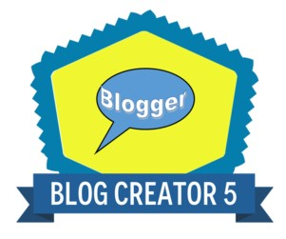 | Creating with ICT is an important skill for researching, and in the workplace, as it enables you to present your solutions or creations in a meaningful way to a particular audience.
Links to the Australian Curriculum  In creating the blog students are showing evidence that they can:  - cultivate and manage their digital identity and reputation and are aware of the permanence of their actions in the digital world.  - engage in positive, safe, legal and ethical behaviour when using technology, including social interactions online.  - demonstrate an understanding of and respect for the rights and obligations of using and sharing intellectual property.  - manage their personal data to maintain digital privacy and security online.  (Applying social and ethical protocols and practices when using ICT element) | Criteria to earn badge  To earn this badge you will:  - Create an online blog.  - Provide a link to your blog.  - Provide a copy of your completed Blog Creation Rubric.  This evidence can then be uploaded when the badge is claimed.
Subject:
Teacher:
Blog Platform:
Link to blog:

Assessment rubric attached:

